**STEPS TO FOLLOW FOR RUNNING FRONTEND(CLIENT) :**

1)Open terminal in zadmin

Run commands

2)dpkg -l | grep nginx

3)docker pull nginx

4)sudo docker ps -a

5)docker run -d -p 80:80 --name mynginx nginx

if it says like this (3689eebb3a227cec34d94c2a3c68e1d8e482b1a1dce547e08d333cb1fd2d22a7

docker: Error response from daemon: driver failed programming external connectivity on endpoint mynginx (e8181b6890403030c11819fac784e3cea055782517ebd8b376a1dd3b4db5882d): Error starting userland proxy: listen tcp4 0.0.0.0:80: bind: address already in use.)

6)Then again sudo docker ps -a

7)sudo lsof -i :80

8)kill 17455

9)sudo lsof -i :80

10)sudo docker ps -a

11)docker run -d -p 80:80 --name mynginx nginx

==> nginx container should be created

12)Then start frontend steps from starting in client terminal

On Linux, install mkcert using the following command

curl -s https://api.github.com/repos/FiloSottile/mkcert/releases/latest \

| grep "browser_download_url.*linux-amd64" \

| cut -d : -f 2,3 | tr -d \" \

| wget -i - -O mkcert

chmod +x mkcert

sudo mv mkcert /usr/local/bin

13)Now cloned the repo in local machine.

14)Now yarn installed as a global npm package, i.e. npm install -g yarn.

Create local HTTPS certificates

15)Run the following command from the project root.

cd app/client/docker && mkcert -install && mkcert "*.appsmith.com" && cd ../../..

This command will create 2 files in the docker/ directory:

_wildcard.appsmith.com-key.pem

_wildcard.appsmith.com.pem

16)Add the domain dev.appsmith.com to /etc/hosts.

echo "127.0.0.1 dev.appsmith.com" | sudo tee -a /etc/hosts

17)Check that the string is copied properly

cat /etc/hosts | grep appsmith

18)Run cmd: cp .env.example .env

19)Run Backend server using command

sudo ./start-https.s

20)Steps to build & run the code:

Run yarn install.

Note:

On the Ubuntu Linux platform, please run the following cmd before step 2 below:

echo fs.inotify.max_user_watches=524288 | sudo tee -a /etc/sysctl.conf && sudo sysctl -p

21)Run yarn start.

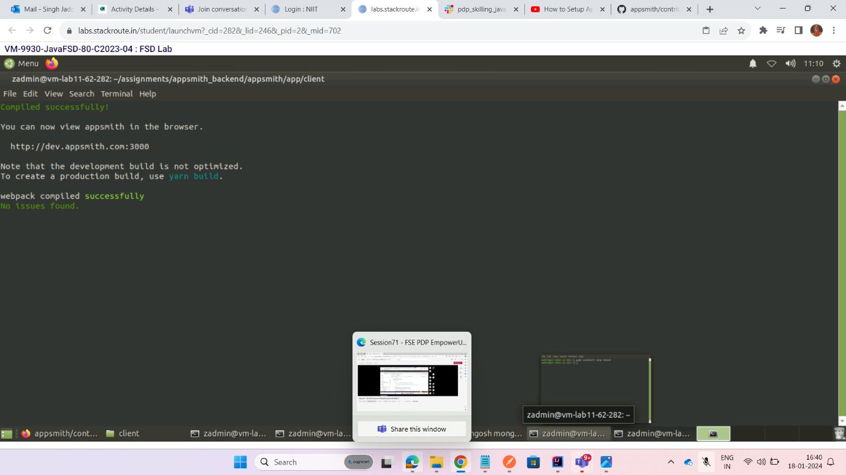

**Now Appsmith client is now running on** [**https://dev.appsmith.com**](https://dev.appsmith.com)**.**

